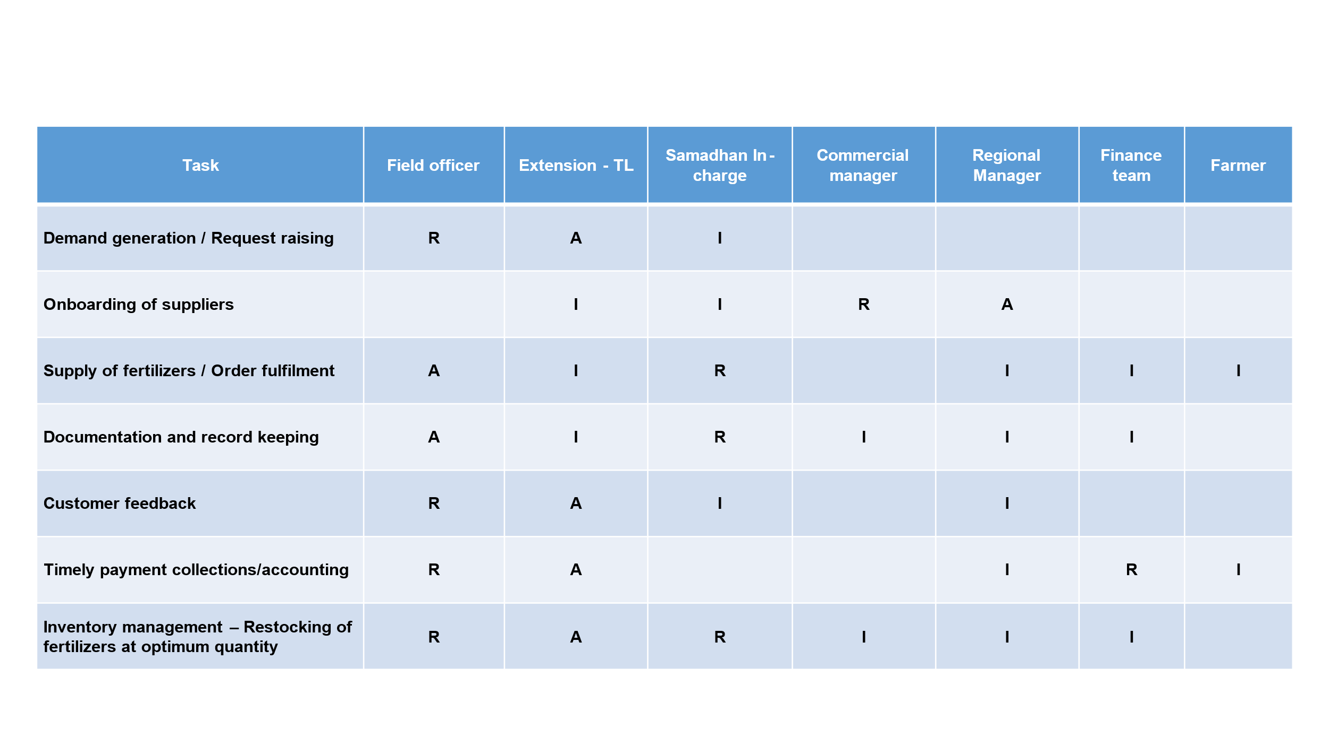

Work sample of **RACI matrix** for sale of products at business units for continuous revenue growth

Sai Mohana Kavya Yerramsetti